**COST ANAYLSIS OF THE QATAR WORLD CUP 2022**

**INTRODUCTION:**

Qatar is a country with a massive export of oil and that enables it to spend massive amounts of money on the modernization of what is a barren land, more likely to be a dessert than an urban city. But in the past years, the amount of capital spent on buildings and infrastructure has enabled Qatar to become a massively developed country and with a population of a mere 2,896,869, as of October 30, this means that the draining of the country’s resources internally is also minimal [6].

This population also has a very interesting dynamic. Foreign workers amount to around 88% of the population. This means that natively only 12% of the people live in Qatar. The majority of this population lives in the capital Doha, almost 92%[7]. This coupled with the change in population of 8.4 per 1000 people means that Qatar does not have an overpopulation issue and that means that the vast resources that the country is able to buy can be distributed generously among the population, but the problem is whether this happens or not [3]. Additionally, the ruling family of Qatar has accumulated enormous amounts of wealth using their oil reserves but that has only meant that the wealth received by Qatar is concentrated among the ruling family and that the local people are still not able to be compensated as they should.

Considering that Qatar has only just begin to realize its tourist potential means that there were previously not many places for recreation. This is not helped further by the climate of Qatar. Qatar is mostly barren flat land which witnesses extremely warm and sunny summers and mild winters [1]. Since Qatar does not have massive ground coverage, this results in uniform temperature throughout the country. This is a weather which discourages outdoor activities and thus, in the past not a lot of attention had been given to providing people with outdoor recreational facilities. Instead, indoor facilities were preffered. This has probably been the reason behind Qatar’s lack of any noteworthy contributions to the world. Even with regards to Qatar’s participation in international events, there is nothing worthy of mention. This can be due to the previously mentioned fact that Qatar has only 12% of native population. But things have changed in recent years. Qatar has become the forefront of one of the greatest sporting events in the world and being related to it so closely means that Qatar can now exploit all the publicity that it is receiving for good measure. Unfortunately, it seems that the people in power in Qatar are not doing a good job doing that.

It was a huge surprise to the footballing world when Qatar was given the rights to hold the FIFA World Cup 2022. Although, this led to a massive investigation and a wipeout followed as many officials in FIFA were found guilty of corruption. However, that wouldn’t change the fact that Qatar was to hold the World Cup in 2022. This was massive news for the Gulf States as they were previously never seen to be a part of the global football community. With this opportunity, Qatar could have state-of-the-art football facilities and an influx of footballing enthusiasm. But this all comes at a cost.

As mentioned above, Qatar does not have the necessary infrastructure required to host such a massive event. That means that in comparison with other countries who have previously hosted a World Cup like Brazil, Germany and France, Qatar is at a major disadvantage since it has to create all the required facilities from the ground up. There is nothing to build upon and Qatar needs to start fresh. This consequently means that it needs vast amounts of wealth, which considering their GDP, would not be a problem. What’s interesting is how would this cost compare to that of the previous World Cups.

That might not be the only difference between the previous World Cups and the upcoming one. Since the temperature of Qatar is hot and humid year-round, this would force the World Cup to be shifted to November-December of 2022 [8], right in the middle of the local league seasons played around the world. Considering the almost all players come from these leagues, which already have very congested playing schedules, the leagues shall have to be moved around the World Cup to make room for it. It surely seems like a controversial decision considering so many factors have been made to consider in order to enable the World Cup in Qatar to be played in the most feasible way possible.

On December 2, 2010, Qatar was announced to be hosting the World Cup in 2022 and what followed was a major outline of the development projects that shall take place in following decade [4]. With a slew of magnificent initial designs and massive influx of workers, engineers, laborers and other people required to put the plan into place, a lot of money was spent and is still being spent so that deadlines can be met and that all the stadiums, facilities, hotels shall be completed before the start of the World Cup on 21st November, 2022.

Unsurprisingly, Qatar would be spending north of $200 billion to be able to host the World Cup in 2022[2]. Comparing this with what Brazil spent in 2014 was $20 billion which is 10 times the amount [6]. $11.8 Billion was spent in 2018 in Russia to prepare for the World Cup [5]. Even considering inflation rates and all other economic factors, the Qatar World Cup would have a final cost like no previous World Cup.

This could have been much higher should the number of stadiums had not been reduced to 8. There were rumors that Qatar would be building more stadiums but the lack of time and a complete lack of infrastructure to speed up the building of these stadiums meant that a feasibility study had to be done and to enable the preparations to be completed before 2022.

**Descriptive Analysis and Graphs:**

The bar plot below shows how the cost has varied over the years and how the cost for the Qatar World Cup appears to be an **outlier** [8]**.** This shows that a country was assigned to host a World Cup with little to no facilities. The graph provides evidence of how much money was required to enable Qatar to be able to host the 2022 World Cup.

Over the course of the selected period from 1990 to 2022, The World Cup costs have varied from a minimum of **$0.5** Billion in USA in 1994 to a staggering maximum of **$220** Billion in the upcoming World Cup. The range of the selected data is therefore **4.6.** The mean spending from FIFA, who provides the word Cup budgets have been **$29.6 Billion**, which is higher than expected because of the spending in Qatar. The variance and standard deviation are **4538.38** and **67.37** respectively.

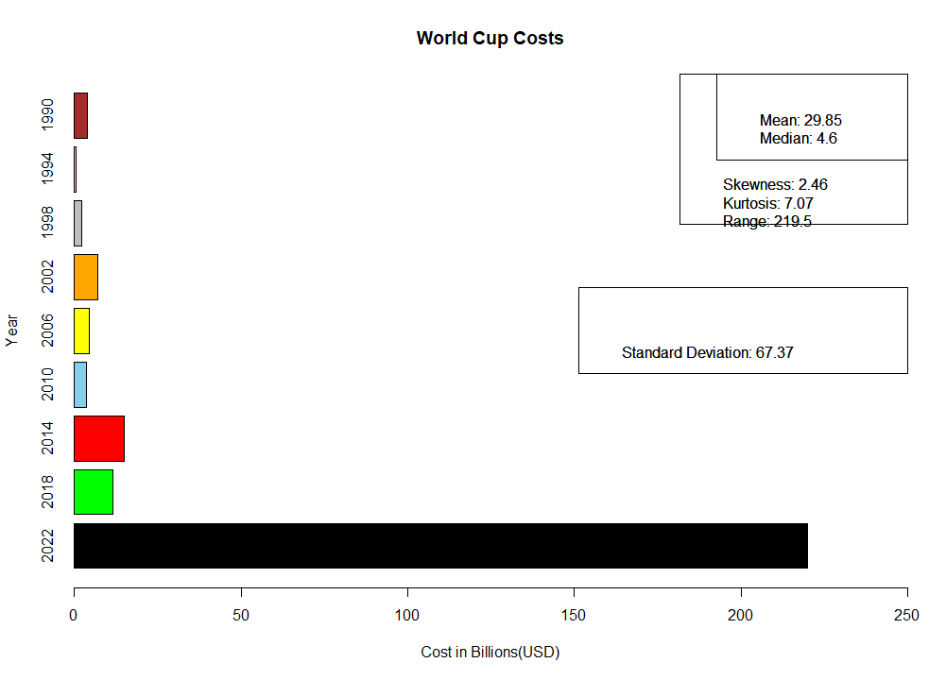

**WORLD CUP BUDGET DIVISION:**

FIFA allocates a budget for every World cup. With regards to the Qatar World Cup of 2022, there has been a massive need for funds. As previously mentioned, Qatar is a country with little footballing facilities and this has led to the construction of numerous new stadiums to host the matches of the upcoming world cup. This is coupled with the construction of hotels and training facilities. The pie chart on the next page categorizes the different sectors in which the money is spent.

This ranges from sectors like World Cup prize money to operational expenses, not considering the spending leading up to the Grand Event. The pie chart shows how the money allocated to a World Cup is spent and even though it might be similar comparing different World Cups, when it comes to Qatar, it is the pre-event costs that have been such a massive figure.

According to the pie chart, majority of the money is allocated towards the winner of the tournament as well as operational expenses which are the expenses incurred during the World Cup. Other expenses include TV Rights and Club Benefits Program.

A total of $1656M were allocated for the different sectors, the division of which has been made accordingly:

|  |  |  |
| --- | --- | --- |
| **SECTOR** | **USD (IN $M)** | **PERCENTAGE PROPORTION** |
| Prize Money | 440 | 26.57 |
| Operational Expenses | 300 | 18.11 |
| TV Operations | 249 | 15.04 |
| Club Benefits Program | 209 | 12.62 |
| Team Services | 120 | 7.24 |
| Workforce Management | 79 | 4.77 |
| Safety and Security | 75 | 4.53 |
| ICT | 68 | 4.10 |
| Marketing Rights | 61 | 3.68 |
| Others | 55 | 3.32 |

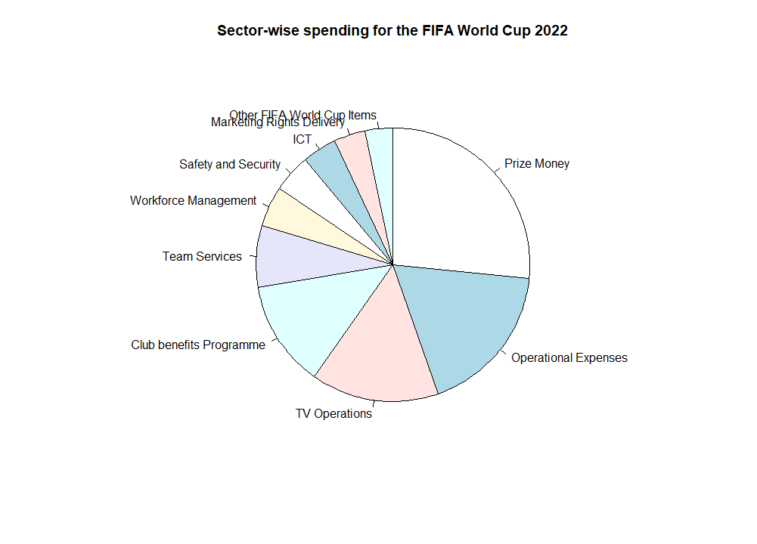These costs might be on par with the previous world cups but the costs leading up to the big tournament have been massive, as described by the bar chart.

**CONCLUSION:**

In conclusion, the controversy regarding the Qatar World Cup is justified specially when comparing the cost of the upcoming world cup with those that have passed. It is not surprising to see such a massive difference between the costs considering all the factors mentioned previously. It is worthy of noting that after the selection of Qatar, an inquiry was held which led to the complete wipeout of Senior Officials in FIFA.

The analysis done on the available dataset comparing previous world cup cost to the upcoming one, has concluded that the World Cup in Qatar will be like no other and the there is still a huge question mark on how much more spending needs to be done to complete all the underway projects in time.

**REFERENCES**

[1]“Climate - Qatar,” *Qatar climate: average weather, temperature, precipitation, best time*. [Online]. Available: https://www.climatestotravel.com/climate/qatar. [Accessed: 02-Nov-2020].

[2]“World Cup 2022 statistics - All stats of the World Cup 2022 football,” *WC 2022*. [Online]. Available: https://www.worldcup2022football.co.uk/statistics. [Accessed: 02-Nov-2020].

[3]“building-a-better-world-cup-protecting-migrant-workers-in-qatar-ahead-of-fifa-2022,” *Human Rights Documents online*.

[4]“The Shocking Statistics of the 2022 Qatar World Cup,” *Visual.ly*. [Online]. Available: https://visual.ly/community/Infographics/sports/shocking-statistics-2022-qatar-world-cup. [Accessed: 02-Nov-2020].

[5]Thesheetztweetz, “Here's who is getting rich off the World Cup,” *CNBC*, 19-Jun-2018. [Online]. Available: https://www.cnbc.com/2018/06/14/the-business-of-the-world-cup--who-makes-money-and-how-much.html. [Accessed: 02-Nov-2020].

[6]J. March and C. Wilson, “The Beautiful Game – The Qatar World Cup 2022,” 2015.

[7]“Demographics of Qatar,” *Wikipedia*, 27-Sep-2020. [Online]. Available: https://en.wikipedia.org/wiki/Demographics_of_Qatar. [Accessed: 02-Nov-2020].

[8]S. Devecioglu, *Cost benefit analysis of the 2022 FIFA World Cup*, p. 75, Nov. 2010.

[9] BostonGlobe.com. 2020. *A Look At Some Of The Money Behind The 2018 World Cup In Russia - The Boston Globe*. [online] Available at: https://www3.bostonglobe.com/sports/2018/06/11/look-some-money-behind-world-cup-russia/sX1o2ZIpFbMDNOUFTKLRsJ/story.html?arc404=true> [Accessed 8 December 2020].

[10] the Guardian. 2020. *South Africa Spent £2.4Bn To Host The 2010 World Cup. What Happened Next? | Quinton Fortune*. [online] Available at :https://www.theguardian.com/football/2014/sep/23/south-africa-2010-world-cup-what-happened[Accessed 8 December 2020].

[11] (www.dw.com), D., 2020. *Germany's World Cup Report Hails Economic, Social Success | DW | 07.12.2006*. [online] DW.COM. Available at: <https://www.dw.com/en/germanys-world-cup-report-hails-economic-social-success/a-2263053> [Accessed 8 December 2020].

[12] The Africa Report.com. 2020. The Cost Of A World Cup. [online] Available at: <https://www.theafricareport.com/9087/the-cost-of-a-world-cup/> [Accessed 8 December 2020].

[13] WikiSpesa. 2020. *Mondiali Italia '90. Sprechi, Opere Incompiute, Mutui Accesi Al 2014*. [online] Available at: https://web.archive.org/web/20140715202303/http://wikispesa.costodellostato.it/Mondiali_Italia_'90._Sprechi,_opere_incompiute,_mutui_accesi_al_2014> [Accessed 8 December 2020].